**Neenjuh**

**Game Pitch**

Ever felt like testing your boundaries? Feel like running and dodging things? Look NO further, Neen-juh is the name, and things coming faster at you is the game! Take a gamble with your time managing obstacle packed speeding running game!

**Objectives**

You decide which goal you prefer achieving, the number of obstacles passed or the time elapsed since start of game. Either way as a Neenjuh you must avoid any collision with an obstacle if you wish to prevail. The end of the screen is a place no Neenjuh wants to be.

**Controls**

The mechanic which I wanted to exploit is the control over gravity. To do this immense feat, one would press the W key to have anti-gravity and the S key to return gravity to it’s original state. The player would press the spacebar to perform a jump and press the spacebar again mid air to perform a double jump, but not a third! Same goes for if you were walking on the ceiling. There is a secret mechanic but it can only be used when you have been hit by an obstacle and your momentum & velocity changes, press spacebar to recover.

**Gameflow**

Being too focused on game mechanics and the struggles were very time consuming making it the main feature of the game so I will be mainly talking about it. The obstacles being the floor, ceiling and pillar are all tracked and spawned accordingly using delta time by the following:

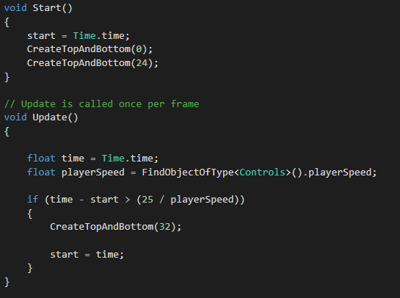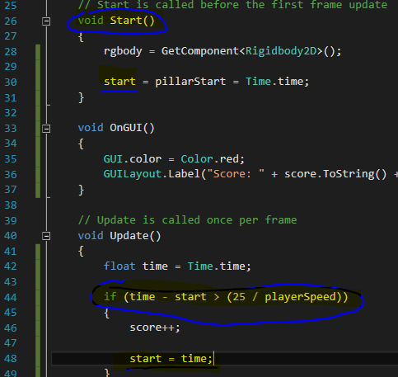

There’s a chance that the floor or ceiling won’t spawn, but never will they both be missing with the following code and logic:

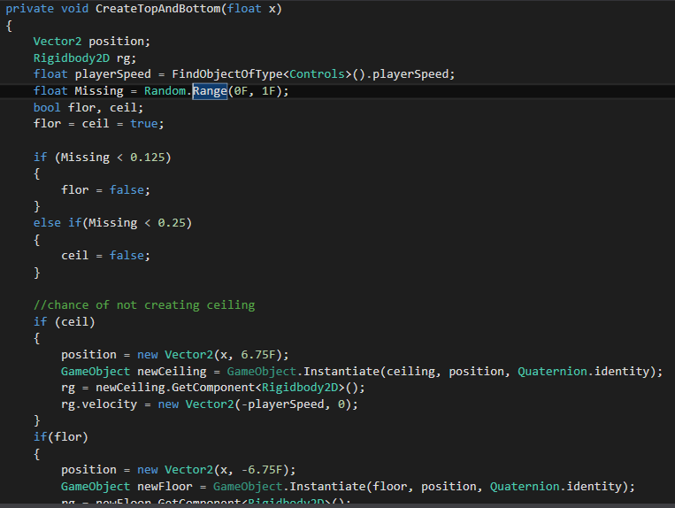

The speed at which they move increase as time goes on with the following line of code 

The following is the logic behind the anti gravity:

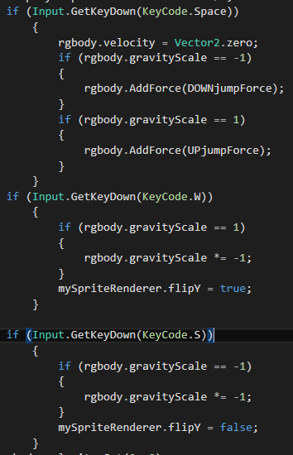

**Screenshots**

When you start the game

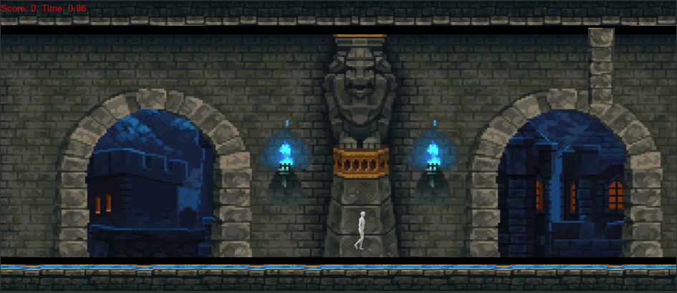

Gravity **REVERSE** with W and S!

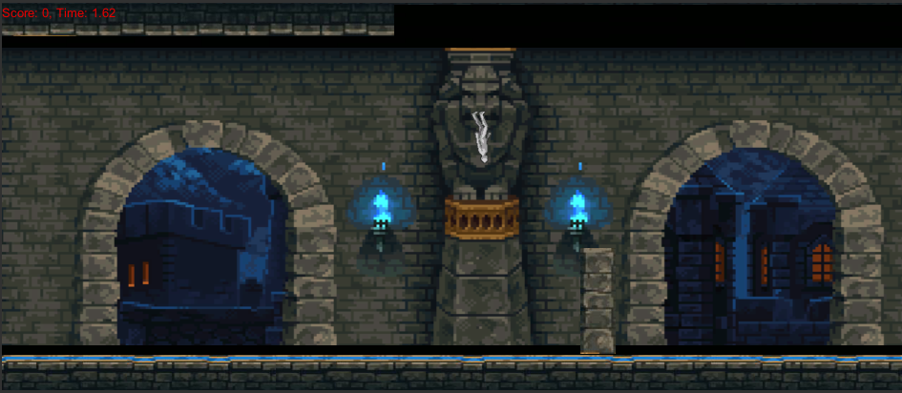

Get **stopped** by Obstacle!

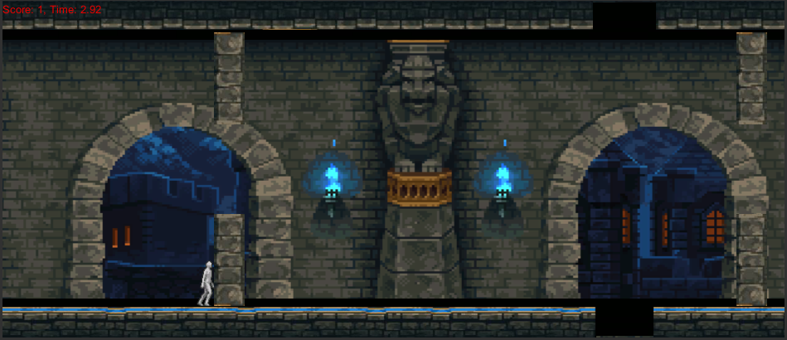

Get stopped by Obstacle… **UPSIDEDOWN**!

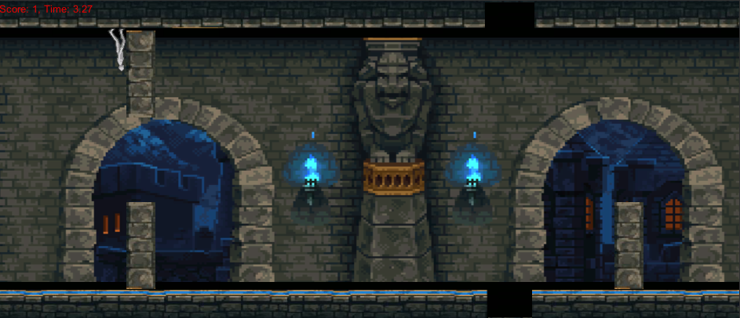

**Jumping** with success

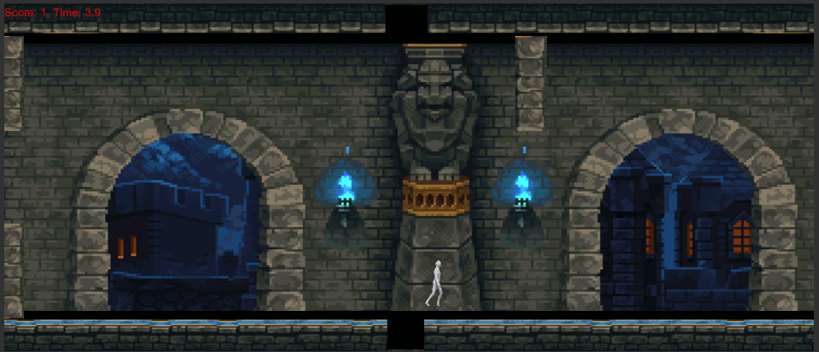

Falling off… successfully

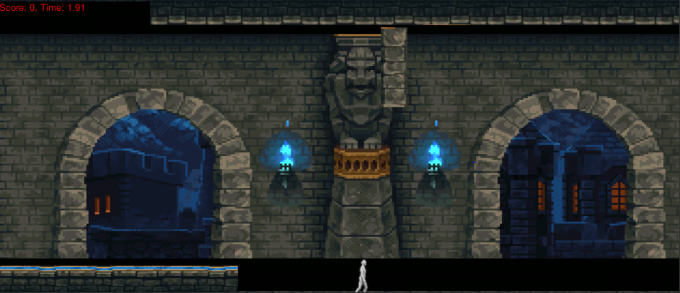

Flying off?... Successfully!?

